**Console Application**

Kyle D. Musegades, Jr.

Colorado State University Global

CSC450-1 Programming III

Professor Reginald Haseltine

October 22, 2023

**Console Application**

**Console Application Documentation:**

#include <iostream>

#include <string>

using namespace std;

int main()

{

std::string string1, string2;

std::cout <<"Please Enter two Strings:"<<endl;

std::cin >> string1 >> string2; //Asks user for two inputs

std::cout <<"Concatenated Strings: "<<string1 + string2<<endl; //Concatenates strings

return 0;

}

***Screenshots of Execution:***

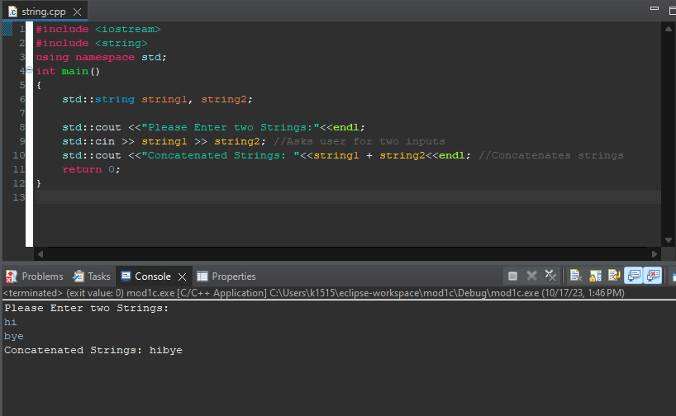

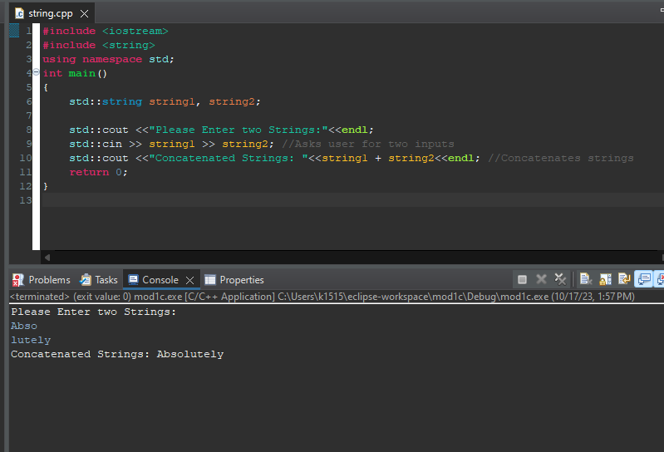

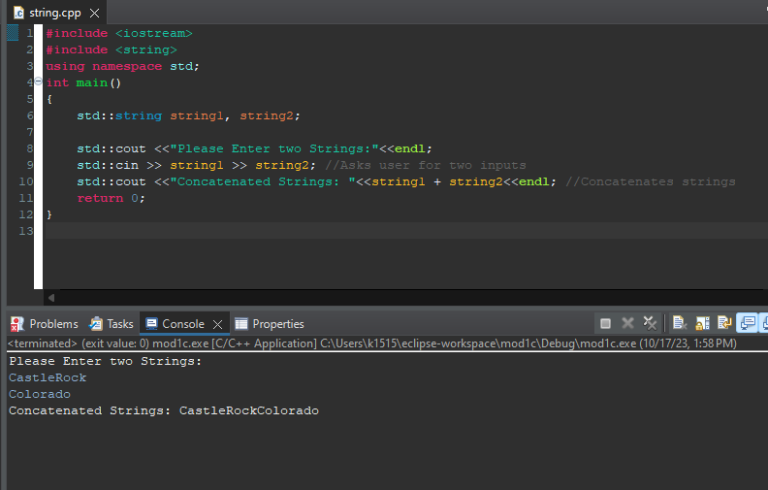

**References**

Ballman, A. (2017). *SEI CERT C++ Coding Standard* (2016th ed.). Carnegie Mellon University. October 10, 2023, https://resources.sei.cmu.edu/downloads/secure-coding/assets/sei-cert-cpp-coding-standard-2016-v01.pdf